This lab requires that you work through recipes 2-1 through 2-7 in the book.

The lab output that you send me does not have to be in APA format. You can send me the output from your labs in several ways:
- Capture screen shots (print screen key) and put them in a Word document
- Log RMAN output (see recipe 17-7 for details) and then put the output in a Word document
- Cut and paste output from your screen into a Word document

I won’t be too picky about the output format, just as long as I can tell that you successfully completed each recipe.

The rest of this document describes how to take an RMAN backup in the Citrix environment. It also describes how to simulate a failure and how to restore and recover using RMAN.

Logon to Citrix.

Click on “Oracle Desktop”

Start up a DOS command window. If there isn’t an icon for this on your desktop, then you can find it in C:\WINNT\system32

The executable name is cmd.exe:
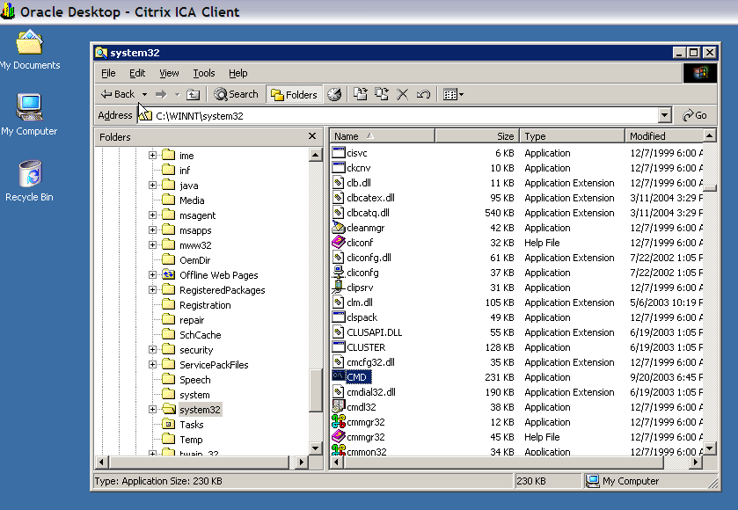

Click on CMD twice to start a DOS command window:

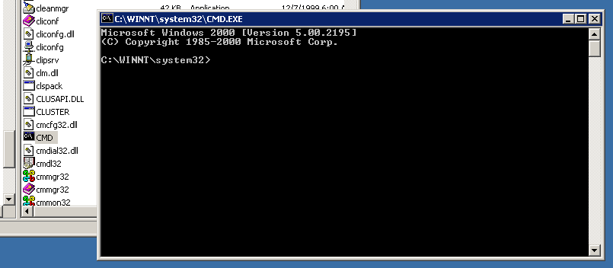

To logon to RMAN:

rman target sys/oracle@<your database>.world

Here is an example:

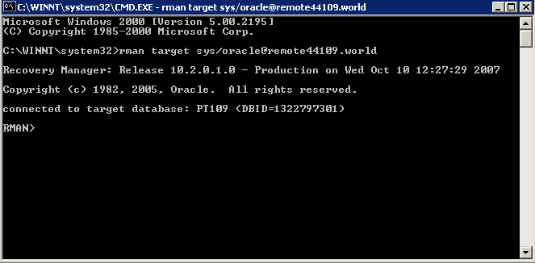

If your database isn’t started, you can start it with the startup command:

RMAN> startup;

You can also shutdown your database with the shutdown command:

RMAN> shutdown;

Your database must be in archivelog mode for an online RMAN backup. If you haven’t enabled archiving, then do so now. Here are the steps for doing this:

Get into SQL*Plus, verify the archive log mode of your database:

SQL> archive log list;

Put your database in mount mode, if your database is open, shut it down, and place it in mount mode.

SQL> shutdown immediate;
SQL> startup mount;

Place database in mount mode:

SQL> alter database archivelog;

Open your database:

SQL> alter database open;

You can also place your database in archivelog mode from within RMAN:

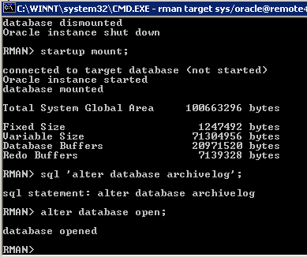

To backup your database:

RMAN> backup database;

The backup should take a couple of minutes.

To verify the RMAN backups:

RMAN> list backup;

To simulate failure:

RMAN> shutdown immediate;

Rename your users.dbf datafile to users.old. You should be familiar with where your datafiles are from the Hot and Cold backup labs.

In Citrix, the datafiles are usually located in a path like:

H:\dbms\app\admin\BK<db number>\oradata\disk2

Try to start your database:

RMAN> startup;

You should see an ORA-01110 error.

Shutdown your database and start it in mount mode:

RMAN> shutdown immediate;
RMAN> startup mount;

Restore your database:

RMAN> restore database;

Recover your database:

RMAN> recover database;

Open your database:

RMAN> alter database open;

